Screw-Loc L-16 Dram Screw-Loc L-30 Screw-Loc 60

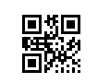 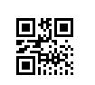 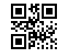

Screw-Loc 16 Lids Screw-Loc 30/60 Lids Liquid 3 oz

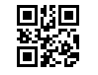 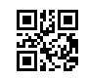 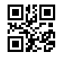

Liquid 4 oz Liquid 8 oz Liquid 16oz

